

217, Sheikh Rashid Building

P.O Box 56272, Dubai

United Arab Emirates

Tel: +971 4 2973236 / 04 2974007

Email: uae@verbat.com

PROJECT   
PROPOSAL

**HAJT Marine & Safety**

|  |  |
| --- | --- |
| **Prepared for:**  Hutchison Ajman International Terminal (HAJT)  Deepak Singh  IT Business Analyst  Ajman, U.A.E | **Submission Date:**  28 Aug2018  **Proposal ID:** AD/BP/28082018/1355/3 |

________________________________________________________________________________________________________________________________  
Conﬁdentiality Notice: This Proposal is conﬁdential and contains proprietary information and intellectual property of Verbanet Technologies LLC. Neither this proposal nor any of the information contained herein may be reproduced or disclosed under any circumstances without the express written permission of Verbanet.

© 2017 by Verbanet Technologies LLC. All rights reserved. Confidential.

________________________________________________________________________________________________________________________________

Project Contacts

|  |  |
| --- | --- |
| Client Information | |
| Project Name | POS Solution Implementation for HAJT |
| Client Name | Hutchison Ajman International Terminal (HAJT) |
| Client Address | Department of Port & Customs Ajman,  P.O.Box 388, Ajman, United Arab Emirates. |
| Phone Number | +971 6 7470 111 |
| Contact Person | Deepak Singh |
| Contact Person Email | [singh.deepak@ajmanport.gov.ae](mailto:singh.deepak@ajmanport.gov.ae) |
| Verbat Information | |
| Contact Person | Ms. Joyce Daniel |
| Contact Person Phone Number | 04 2973236 |
| Contact Person E-Mail | Joyce.daniel@verbat.com |
| Address | PO Box 56272, Dubai |
| Physical Address | Flat 217, Sheik Rasheed Building, Hor Al Anz East, Dubai |
| Project Information | |
| Anticipate Start Date | NA |
| Proposal Valid For | 30 Calendar days from the submission of the proposal |

**Table of Content**

1 Executive Summary 5

1.1 Solution Objective 5

1.1.1 Marine Services 6

1.1.2 Safety Services 6

1.2 Advantages of Proposed Solution 8

1.3 Why Verbat 9

1.4 Key Differentiators 10

1.5 Underlying Support Services 11

2 Functional Specification 12

3 Non Functional Requirements 13

4 Assumptions 13

5 Out of Scope 14

6 Technology Solution 16

6.1 Technical Configuration 16

6.1.1 Development Tools 16

6.1.2 Hardware Interface 17

7 Commercials 17

7.1 POS Solution 17

7.2 Payment Terms 17

7.3 Mode of Payment 18

8 Delivery Management 18

8.1 Project Management 18

8.2 Roles and Responsibilities 19

8.3 Delivery Activity Summary 19

8.4 Project Implementation plan 20

8.5 Deliverables 20

8.6 Estimated Delivery Time 20

8.7 Deployment Details 21

8.8 Release Planning 21

8.9 Risk and Contingency planning 22

9 Change Management 23

10 Miscellaneous 25

10.1 Warranty 25

10.2 Acceptance Criteria 25

10.3 General Terms and Conditions 25

10.4 Assumptions and Dependencies 26

10.5 Source Code & Intellectual Property Rights 27

10.6 Maintenance & Support 27

10.7 Service Level Agreement 28

11 Our Clients 29

# Executive Summary

**Hutchison Ajman International Terminals Limited - F.Z.E.** is the port and related services division of **CK Hutchison Holdings Limited (CK Hutchison)**. Hutchison Ports is the world’s leading port investor, developer and operator with a network of port operations in 48 ports spanning 25 countries throughout Asia, the Middle East, Africa, Europe, the Americas and Australasia.

**Hutchison Ajman International Terminals Limited - F.Z.E.** (hereafter referred to as “Client”) has approached **Verbanet Technologies LLC.,** trading as Verbat Technologies (hereafter referred as” Verbat”) to develop a Marine and Safety Services workflow automation application.

Developing web based applications using Microsoft .Net services is an area where Verbat has in-depth knowledge and expertise. Being the pioneers in Web based and windows based solutions across the major verticals, we are sure to help you enhance your customer engagement to drive differentiation. We bring proven methodologies and processes, global expertise in application development, and a legacy of best practices and ready-to-fit frameworks to expedite the development cycle and reduce the total cost of ownership.

Verbat is pleased to have received the request to submit the proposal and values it as a great opportunity to have a long term & mutually beneficial association with the client. Verbat has gone through the requirement and presents the proposal for the requested system. With the focus of delivering value to client, Verbat proposes a stand –alone fixed bid solution model for this requirement.

## Solution Objective

Verbat will develop a web based .net based application to automate the following services namely

### Marine Services

It includes the automation of

* Vessel Berthing
* Sail Out Permits
* Extend vessel berthing stay
* Vessel permit to enter Ajman port

### Safety Services

It includes the automation of

* Bunker permit
* Hot works permit
* Diving permits
* Diesel discharging permit
* General maintenance
* Sanitation

Additionally the sites needs to provide

* Bilingual Support (Arabic and English)
* Customer Dashboard
* DPC/HAJT reports

The scope of the system includes:

* System Study, Design & Development of POS Solution
* QA & UAT

## Actors

Actors are the users of the automated web app on Safety and Marine Services

* **Customer:** submits request for approval
* **Safety Officer:** Approves/rejects the requests regarding safety services
* **Port Control Officer:** Approves/rejects the requests regarding Marine services
* **Other Users:** DPC/HAJT business users, systems team, operation team, finance team & other business teams

## Workflows

### Safety Workflows

* Bunker Permit
* Hot works Permits
* Diving Permits
* Diesel Discharging Permits
* General Maintenance Permit
* Sanitation Permit

### Marine Workflows

* Vessel berthing post NOC approval
* Sail out permit
* Extend vessel berthing stay
* Vessel permit to enter Ajman Port

### Common Marine and Safety Services

* Bilingual Software ( English & Arabic)
* DPC(Department of Port & Customs)/HAJT(Hutchison Ajman International Terminal)

Reports

* Customer Dashboard

# Solution Details

## Safety Services

### Bunker Permit Process Flow

* Registered customer fills online form, attaches required documents and submit request for approval
* The safety officer will approve or reject the request, system will follow one of the workflow
  + The safety officer will approve request and system will send approved permit as an email attachment
  + The safety officer will provide mandatory comments for rejection and system will notify the customer
* 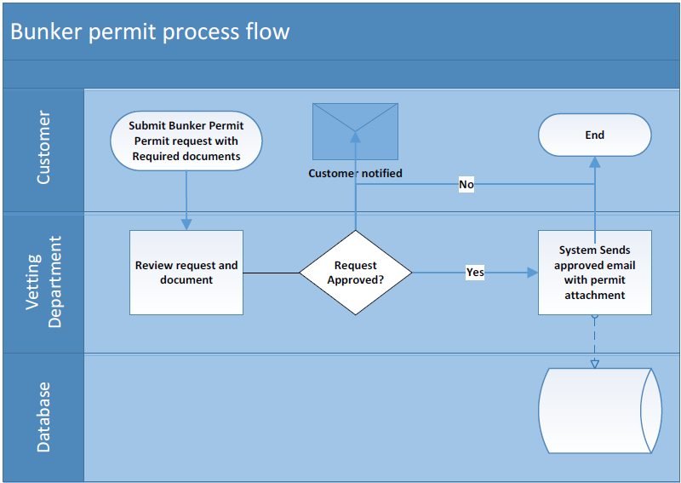On rejection customer will submit a new request with valid documents

#### Bunker Permit Process flow

#### Bunker Permit Form Data Fields

#### Bunker Permit required documents

#### Email notification trigger points

#### DPC/HAJT user’s Roles & Privileges

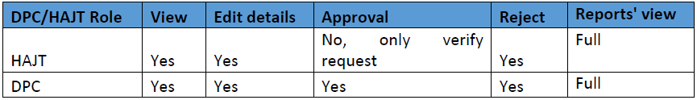

### Hot Work Permit Process Flow

* Registered customer fills online form, attaches required documents and submit request for approval
* The safety officer will approve or reject the request, system will follow one of the workflow
  + The safety officer will approve request and system will send approved permit as an email attachment
  + The safety officer will provide mandatory comments for rejection and system will notify the customer
* On rejection customer will submit a new request with valid documents
* The certified marine surveyor certificate is valid for 24 hours. Therefore, the request should be submitted as soon as possible

#### Hot Work Permit Process flow diagram

#### Hot Work Permit form data fields

#### Hot Work Permit required documents

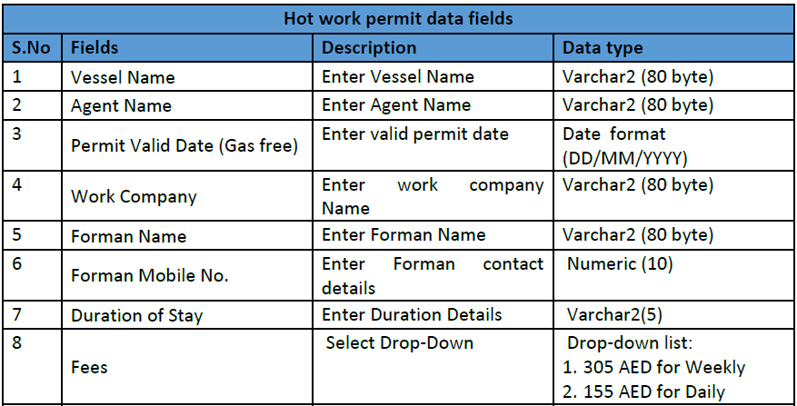

#### Email notification trigger points

#### DPC/HAJT user’s Roles & Privileges

### Diving Permit Process Flow

* Registered customer fills online form, attaches required documents and submit request for approval
* The safety officer will approve or reject the request, system will follow one of the workflow
  + The safety officer will approve request and system will send approved permit as an email attachment
  + The safety officer will provide mandatory comments for rejection and system will notify the customer
* On rejection customer will submit a new request with valid documents

#### Diving Permit Process Flow

#### Driving Permit form data fields

#### Diving Permit required documents

#### Email notification trigger point

#### DPC/HAJT user’s Roles & Privileges

### Diesel Discharge Point Process Flow

* Registered customer fills online form, attaches required documents and submit request for approval
* The safety officer will approve or reject the request, system will follow one of the workflow
  + The safety officer will approve request and system will send approved permit as an email attachment
  + The safety officer will provide mandatory comments for rejection and system will notify the customer
* On rejection customer will submit a new request with valid documents

#### Diesel Discharge permit process flow

#### Diesel Discharge Permit Form data fields

#### Diesel Discharge Permit required documents

#### Email notification trigger point

#### DPC/HAJT user’s Roles & Privileges

### General maintenance Permit Process Flow

* Registered customer fills online form, attaches required documents and submit request for approval
* The safety officer will approve or reject the request, system will follow one of the workflow
  + The safety officer will approve request and system will send approved permit as an email attachment
  + The safety officer will provide mandatory comments for rejection and system will notify the customer
* On rejection customer will submit a new request with valid document

#### General maintenance Permit Process Flow

#### General Maintenance Permit form data fields

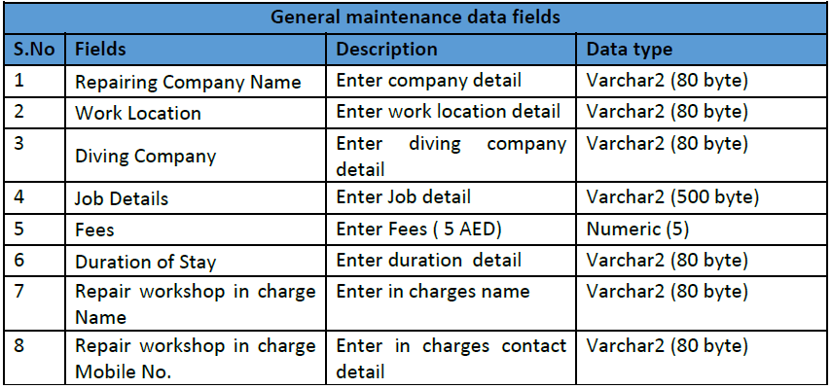

#### General maintenance Permit required documents

#### Email notification trigger point

#### DPC/HAJT user’s Roles & Privileges

### Sanitation Permit Process Flow

* Registered customer fills online form, attaches required documents and submit request for approval
* The safety officer will approve or reject the request, system will follow one of the workflow
  + The safety officer will approve request and system will send approved permit as an email attachment
  + The safety officer will provide mandatory comments for rejection and system will notify the customer
* On rejection customer will submit a new request with valid document

#### Sanitation Permit Process Flow

#### Sanitation Permit form data fields

#### Sanitation Permit required documents

#### Email notification trigger point

#### DPC/HAJT user’s Roles & Privileges

### DPC/HAJT Reports

* Able to get reports by date range
* Able to get reports by status
* Able to use all combination filter
* Able to get all reports despite of date range
* Able to get reports by user name (All reports should be saved/printed in excel/Pdf)

## Marine Services

### Vessel Berthing Process Flow

* The existing online system will be enhanced
* The registered customer fills online form, attaches required documents and submits request for approval
* The port control officer will either approve or reject request, and system follow below workflow
  + Approve: The port control officer will approve NOC and system will send approved NOC letters as an email attachment
  + Reject: The port control officer will provide mandatory comments for rejection and system will notify the customer
* In case of rejection customer submits a new request with valid documents
* Post NOC letter received by the customer, the customer must get the coast guard and immigration clearance to enter the port.

#### Vessel Berthing Process Flow

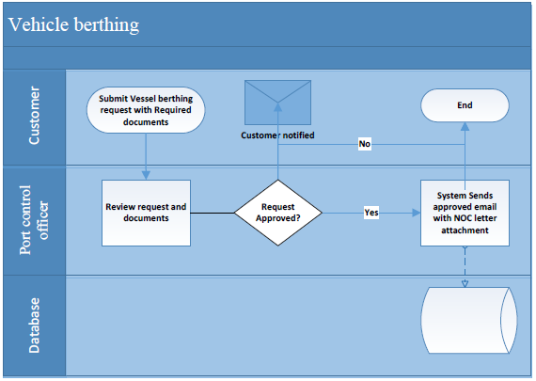

#### Vessel Berthing required documents

#### Email notification trigger points

#### DPC/HAJT user roles & privileges

### Sail Out Permit Process Flow

* The registered customer fills online form, attaches required documents and submits request for approval
* The port control officer will either approve or reject request, and system follow below workflow
  + Approve: The port control officer will approve and system will send approved NOC letters as an email attachment
  + Reject: The port control officer will provide mandatory comments for rejection and system will notify the customer
* In case of rejection customer submits a new request with valid documents

#### Sail Out Process Flow

#### Sail Out Permit form data fields

#### Sail Out Permit required document

#### Email notification trigger points

#### HAJT user roles & privileges

### Extend Vessel Berthing Stay

* The registered customer fills online form, attaches required documents and submits request for approval
* The port control officer will either approve or reject request, and system follow below workflow
  + Approve: The port control officer will approve and system will send approved NOC letters as an email attachment
  + Reject: The port control officer will provide mandatory comments for rejection and system will notify the customer
* In case of rejection customer submits a new request with valid documents

#### Extended Vessel Berthing Process Flow

#### Extend Vessel Berthing data fields

#### Extend Vessel Berthing required documents

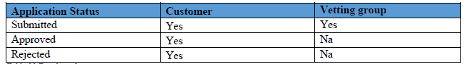

#### Email notification trigger points

#### HAJT user roles & Privileges

### Vessel Permit to enter Ajman Port

* The registered customer fills online form, attaches required documents and submits request for approval
* The port control officer will either approve or reject request, and system follow below workflow
  + Approve: The port control officer will approve and system will send approved NOC letters as an email attachment
  + Reject: The port control officer will provide mandatory comments for rejection and system will notify the customer
* In case of rejection customer submits a new request with valid documents

#### Vessel Permit to Ajman Port Process Flow

#### Vessel Permit for Ajman data fields

#### Vessel Permit for Ajman required documents

#### Email notification trigger points

#### HAJT user roles and privileges

### DPC/HAJT Reports

* Able to get reports by date range
* Able to get reports by status
* Able to use all combination filter
* Able to get all reports despite of date range
* Able to get reports by user name
* All reports should be saved/printed in excel/Pdf format

## Common Safety & Marine Service

### Customer Dashboard

This section covers the dashboard requirements for customers

* List of submitted requests
* List of approved requests
* List of rejected requests

### Email notification message

#### Submission Email Content

Dear User (XXXX),

Your (request name) for (request no.) has been received and is being considered

You will be advised by mail when a decision has been made

Regards

Marine/Safety Department

HAJT

#### Approved Email Content

Dear User (XXXX),

Your (request name) for (request no.) has been approved

Please find the attachments for your reference and follow below instructions for entry

Instructions:

1. Payment must be made at payment counter prior to entry(conditional)
2. Approved Permit

Regards

Marine/Safety Department

HAJT

Verbat’s Solution architects have conducted a thorough research on the requirements and have come to the conclusion that our proposed solution, which is detailed further in this document, will meet the requirements put forth by the client. And the proposed solution will be delivered as per Verbat’s stand-alone fixed bid solution model.

**Strong and Scalable platform:** The platform proposed will be strong and scalable enough to accommodate future enhancements.

**Accelerated solution:** The framework would act as a solution accelerator. It would provide the basic building blocks which could be reused in future for building new components and features as part of enhancements

**High performance:** The light weight framework used consumes fewer system resources thereby making the application perform faster

**Security:** The application will be developed considering various aspects of security.

* Database Server shall be housed in a secure location, either on the client’s premises or on the cloud
* Only authorized personnel shall have access to the system
* Encryption shall be used to secure sensitive information

## Advantages of Proposed Solution



01

Agile development offering reliable, scalable and secure solution

02

Smooth transition and quicker completion of processes

03

User friendly interfaces enabling easy navigation between screens

## Why Verbat

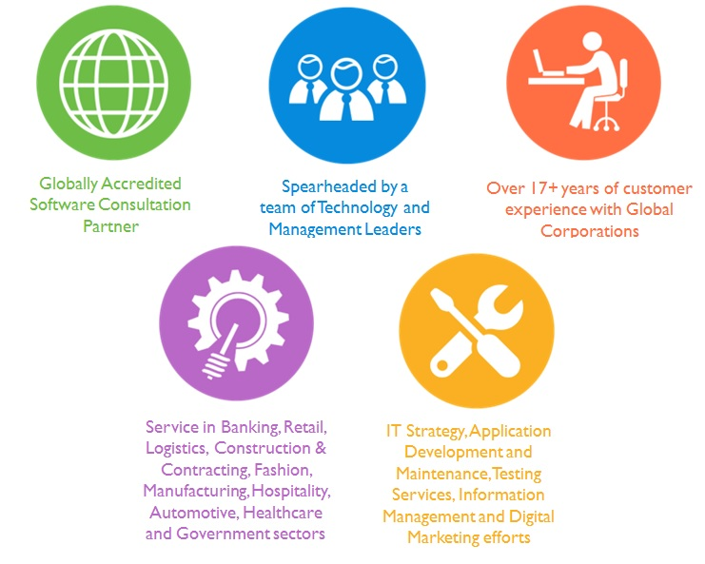

## Key Differentiators

Delivered digital transformation expertise to global customers for over a decade by following industry best practices to maximize ROI for client

Keen technology intelligence combined with aggressive market research to deliver solutions that achieve results with measurable value

Enable access to global consulting expertise with strong local market and business knowledge

Commercial Model that is customizable for your business needs

Services that are designed to optimize applications for improved performance and overall efficiency

1,000,000 plus man-hours of expertise in technology frameworks spanning Microsoft, Open Source, mobility platforms and other proprietary IT technology

Partners top technology vendors to bring in the latest and best services in integration, collaboration, and development

Commercial Model that is customizable for your business needs

Proven Methodologies & Processes

Investment in R & D

Strong Local Presence

Flexible commercial Models

Technology Associations

Software Development Experience

Offshore Development Centre

Quality Assurance & Testing

## Underlying Support Services

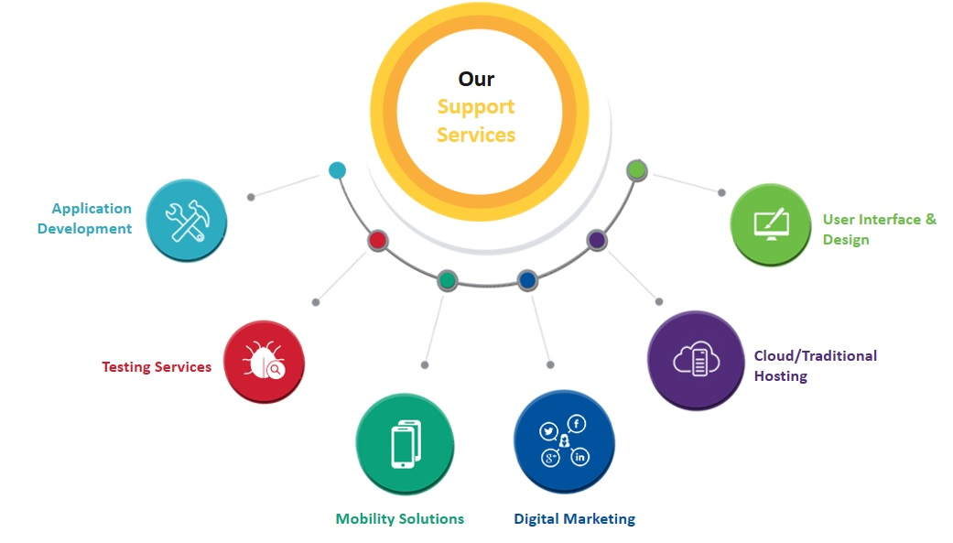

# Functional Specification

|  |
| --- |
| **User - Customer** |
| *User Registration* |
| *Login* |
| *Dashboard, Notifications* |
| **Marine Services** |
| *Marine service form* |
| *Sail out Permit form* |
| *Extension vessel berthing form* |
| *Vessel permit form* |
| **Safety Services** |
| *Bunker permit request* |
| *Hot work permit request* |
| *Diving permit process* |
| *Diesel discharge permit* |
| *General maintenance permit* |
| *Sanitation permit process* |
| **User - DPC/HAJT User** |
| *Login (Assign services according to the roles)* |
| *Dashboard, Notifications* |
| **Marine Services - View/ Edit details, Approval/Reject** |
| *Marine service (Listing with search)* |
| *Sail out Permit (Listing with search)* |
| *Extension vessel berthing (Listing with search)* |
| *Vessel permit (Listing with search)* |
| **Safety Services** |
| *Bunker permit request* |
| *Hot work permit request* |
| *Diving permit process* |
| *Diesel discharge permit* |
| *General maintenance permit* |
| *Sanitation permit process* |
| **Reports (for each service) 10 services (Save as PDF & Excel)** |
| *10 Reports. Each having maximum 4 filters* |
| *Report by date range* |
| *Report by status* |
| *Report using all combination filter* |
| *Report despite of date range.* |
| *Report by users name* |
| **Email attachments reports (PDF Format)** |
| *Vessel berthing* |
| *Port clearance/ Sail out* |
| *Extend vessel stay(2)* |
| *Vessel permit to enter Ajman port* |
| *Safety section* |
| *Hot work permit and safety induction* |
| *Diving permit and safety induction* |
| *Diesel discharge permit and safety induction* |
| *General maintenance permit and safety induction* |
| *Sanitation permit and safety induction* |
| **User - Administrator** |
| *Master entries - both in English and Arabic* |
| *Countries, Fees, Agents, Exit Ports, Hot work Fees,* |
| *User Management* |
| *User Role Management* |
| *Manage Requirment docs for services* |
| *Manage Email templates (Approve, Reject, Received)* |
| *Manage Email notification trigger points (10 services - 3 status mails)* |
| **System** |
| Login, forgot password, remember password, Password salting |
| Bilingual Site (Includes saving data in Arabic) |
| Authentication and Authorization |
| Auditing and logging |
| Email, SMTP |
| Exception Handling |
| File management |
| HTTPS, SSL |

# Non Functional Requirements

|  |  |
| --- | --- |
| **Requirement** | **Details** |
| User Experience and  UI Design | * The application will be developed in English and Arabic * The layout and graphical components will be created considering the usability factors |
| Performance | * Application will allow users to have smooth and quick access to the information or services they require. |
| Security | * Web security standards will be followed. |

# Assumptions

The project solution and technology is created from the initial understanding of the requirement shared with Verbat through mails and meetings. The proposed solution is based on the following assumptions;

* Color theme shall be provided by the client
* Client shall provide licensed images and logos in specified size & format as well as branding guidelines
* Verbat is free to use custom made template for design, if required.
* Client shall provide the text and associated images for languages other than English
* Client shall purchase SSL certificates
* Estimate provided for developing a brand new application from ground up
* Email attachments / Print outs will be system generated (Not in pre-printed bills).
* Bilingual Site - The application will be viewable in both English and Arabic, Data entry can be done either languages.

# Out of Scope

With the ever evolving digital market, the requirement needs to be clear to both the parties involved, hence the importance of mentioning the out of scope details of the project. Following are considered to be out of scope while creating this proposal.

* Purchase of images, fonts
* Adding new features to the application other than mentioned in this proposal
* Any language other than English & Arabic
* SMS Gateway Integration
* SSL Purchase and installation
* Manual data entry
* Hardware Integrations / procurement and purchase
* Database migration
* Content or image procurement or uploading or editing.
* Content writing / proof reading
* Hosting Infrastructure and Maintenance
* Annual Maintenance of the application (Bug fixing, debugging) - For AMC details, please refer section 11.5 titled “Maintenance and Support”
* Physical deployment onsite / installation of the application in devices
* Data Replication
* Application deployment
* Integration with SharePoint application not considered
* CMS integration has not been considered in the proposal
* Web service development is considered out of scope. A separate estimate shall be provided if the clear requirements are provided

# Technology Solution

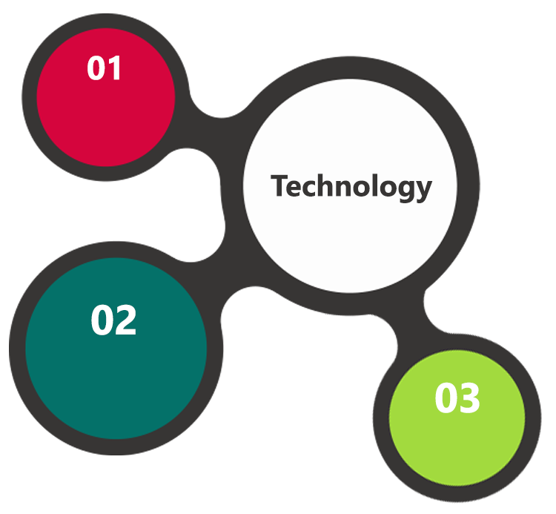

C#, MVC 4.0, EF

.Net 4.5

Oracle 11g  
Windows 2012 OS

SSL, IIS 7.0

HTML 5  
JavaScript  
CSS3

A major portion of the application will be developed using Microsoft technology employing a mix of web services and web interfaces to configure the application.

## Technical Configuration

### Development Tools

* Visual Studio
* Oracle, IIS & Photoshop
* .NET SDK

### Hardware Interface

The application is reliant on hardware interfaces to provide a seamless automated user experience.

* Computer with Windows 8 or 10 OS
* Oracle DB Server

# Commercials

## Web Application

|  |  |  |
| --- | --- | --- |
| **No** | **Description** | **Amount (AED)** |
|  |  |  |

*Note:*

* *The above cost is based on the initial understanding of the requirement grounded on the details shared by client. Any further changes in the scope or complexity if encountered during system study/ analysis will call in for additional effort and time.*
* *The above cost does not include Application hosting, any other integration other than included in the scope, deployment.*
* *For change management cost, please refer to section 10 titled Change Management*

## Payment Terms

*Note: Payment should be made within 7 days from the date of the invoice*

## Mode of Payment

By Cheque / DD to Verbanet Technologies LLC

OR

Wire transfer to our bank account

Bank Name : Emirates NBD

Account Name : Verbanet Technologies LLC

Account Number : 1011492858201

IBAN Number : AE61 0260 0010 1149 2858 201

Swift Code : EBILAEAD

Bank Address : Mamzar Branch, Dubai

*Note: Bank charges incurred during wire transfer to be borne by the client. Any local taxes applicable to be borne by the client*

# Delivery Management

## Project Management

The Verbat development center strictly follows industry standards on quality. The project management is process governed by the Verbat Quality Management system and is put to verification through internal audit programs that happen from time to time.

Verbat will dedicate a project manager for the proposed implementation. Verbat proposes Client to identify one project manager who will be driving activities to be undertaken by Client to be the single point of contact for Verbat.

## Roles and Responsibilities

Verbat will assign a dedicated Project Manager/Project Lead to lead the project, who will be the first point contact for Client. He/she will be responsible for planning and managing the various activities within the project. He/she will work closely with Client Project Manager, to give periodic status updates and ensure high level of visibility and comfort on the progress of the project.

The Project Manager/Project Lead will lead the co-ordination between Verbat and Client, thus enabling smooth transitioning of Client requirements to the Verbat’s offshore delivery team, and provide visibility as well as comfort on the progress of the services to Client.

He/she will have periodic meetings with Verbat’s Senior Management, thus ensuring Verbat’s Management commitment and focus on Client initiatives.

*Note: detailed qualification and experience of the persons involved in the project will be shared be finalizing the project on request*

## Delivery Activity Summary

|  |  |
| --- | --- |
| Activities | Description |
| Detailed requirement Analysis | Verbat team to conduct detailed study of requirement for the phase. If clarification is required, team will reach out to Client for more information and/or time for discussions. |
| DB Design | DB design for central and test DB. |
| Software Requirement Specification document (SRS) | Once the requirement analysis is completed, Verbat team will submit the SRS document for approval |
| UI/UX Design, Prototyping | Based on the SRS, Verbat UX/UI team will work on the UI/UX of the screens and submit a prototype for approval |
| Functional Specification Document (FS) | Once the Prototype. UI/UX is approved, Verbat shall submit an FS document for approval. |
| Development | Actual system development starts based on the FS. This involves detailed design and software development of Web Application. |
| Testing | Test Planning, test plan creations, internal, integration testing and user acceptance testing. |
| Deployment | Deploying the latest built in the Verbat Test Server. |

## Project Implementation plan

Verbat will be providing the solution in a phased approach which ensures minimum viable solution for quick wins with core focus on the long term business objective and outcome. Once the implementation of phase 1 is over, Verbat will initiate the application maintenance process which continues to extend after the implementation of successive phases.

## Deliverables

* Software Requirement Specification Document (SRS)
* Prototype of the application
* Functional Specification Document (FS)
* Fully Developed & Tested Application
* Install shield executable

## Estimated Delivery Time

Delivery of working prototype: ~2 weeks

Delivery of the entire application: 2 months from the sign off of the Working Prototype

| **Activity** |
| --- |
| Contract Signoff (T0) |
| Project Initiation & Initiating requirement gathering |
| Software Requirement Specification Document(SRS) |
| SRS Approval (T1) |
| System Prototype-Complete |
| System Prototype-Approval (T2) |
| Functional Specification (FS) |
| FS Approval (T3) |
| Development Phase-Complete |
| Perform QC (Unit Testing and Integration Testing) |
| System ready for UAT |
| UAT Acceptance on Verbat server (T4) |
| Release of the application with source code to client |

## Deployment Details

* Client can opt for hosting the application at Verbat’s Server.
* If deployment is at the client’s server, responsibility of deploying the application onto the production environment after conducting the necessary acceptance testing will lie with the client unless and until Verbat’s support is contracted for deployment.

***Note****: Hosting the application at Verbat’s server will call in for additional charges*

## Release Planning

* Client will be informed about the release date and time through email.
* Client performs the UAT

## Risk and Contingency planning

Verbat has identified various risk factors associated with this assignment and understands the impact of these risk factors on the project schedules. The objective of this section is to highlight for both Verbat and client, the risk factors, to analyze the impact of the risks on project execution, and to propose strategies to control and reduce the impact of the risk factors.

These various risks, which could arise during the project, are tabulated below along with mitigation implementation.

| Type of risk | Impact | Risk Mitigation | Risk Handling |
| --- | --- | --- | --- |
| Scope Creep | H | Functions and features will be detailed in system requirement documents and will go through client approval. Once this document is approved, any change to requirement will go through change management review for possible impact assessment. | Proper change management procedure will be implemented. |
| Delay in customer feedback | H | The plan is prepared with enough lead-time for customer reviews and approvals.  The customer is indicated with the dates when the document is expected after review and approval. | The request for feedback will be escalated if not attended at the right time so that the schedules are not affected. Deemed acceptance criterion is set up front and will be followed. |
| Non-availability of necessary software’s, frameworks, database instances and infrastructure at client’s hosting environment(If hosting support is provided by Verbat) | M | Client will be informed in advance on these requirements. | Possible impact to schedule. |
| Manpower attrition | L | All efforts would be made to ensure process dependence rather than being person dependent. As a risk mitigation plan Verbat will train backups. | A new person will be identified as early as possible, provided the required project-specific training and mentored by the senior members of the team to minimise impact of attrition on the project. |

*H-High, M-Medium, L-Low, NA-Not Applicable*

# Change Management

Any addition which comes out of the project scope, upon and after the launch of the tool will be considered as change management. Verbat recommends the following change management procedure for the same.

* Any change which comes out of the project scope, which was discussed, documented, and mutually approved by both the parties in the requirement stage, will be carried out only through raising a change request.
* Change request will be studied and an impact analysis on the existing work flow will be performed.
* On finalizing the impact, effort estimation for the change will be calculated and raised as additional requirement.
* Verbat will initiate the change request only after getting a formal approval from the client for the additional changes raised.
* Any change from the scope will be charged at **AED 1200 per man day effort** and approval from the clients will be availed before commencing on any change management.

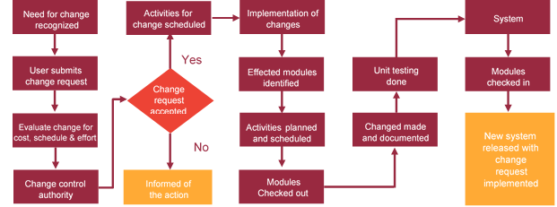

# Miscellaneous

## Warranty

Verbat shall provide a bug ﬁx warranty at no additional cost for 30 days or with additional cost for 1 year from the date of acceptance of the project, for correction of any errors in the developed application that may be attributed to Verbat.

However, this does not cover modifications by Client, or use of the application on an environment other than the proposed environment, or other circumstances outside Verbat’s reasonable control. In such a case Verbat reserves the right to charge for its services.

All error corrections will be executed at Verbat India office. In the event of any need for on-site work, all expenses incurred for such trips will be payable to Verbat by Client.

## Acceptance Criteria

* UAT sign off should happen within 7 Days from the release of each module/ Phase and the acceptance confirmation needs to be mailed to Verbat failing which Verbat will consider the project as approved by the client.
* Any comments or reason for rejection need to be documented and the same needs to be sent as an email from the official mail id of client to Verbat.

## General Terms and Conditions

* Offer Valid for 30 calendar days from the date of submission of the Proposal
* An average of 20 working days are assumed in a month
* This proposal and all technical/ functional specifications have been derived or concluded from the data shared via email / information's transferred during the initial requirement analysis meetings and conversations. Verbat reserves the right to amend the terms of this proposal, should the SOW terms, functional features and functionalities change during the course of the project
* The applications will be built as per the specifications agreed mutually. Any changes will be executed through a deﬁned change management process between both parties
* All Source Code and other project artefacts would adhere to the Verbat document templates and internal coding standards
* Acceptance criteria shall be based on the clauses which were mutually discussed between Verbat and client at the Requirement Analysis phase and the same will be documented and approved by both parties through official emails
* Final deployment to production server pursuant to completion of all payments

## Assumptions and Dependencies

* During the requirement gathering phase, authorized personnel from the Client’s side is expected to be available for discussion and finalizing the HLD (High Level Design), before development commences.
* Type of reports and formats, if under the scope of the project, needs to be specified by Client before project sign off.
* Workflows need to be specified/ confirmed by client before project signoff.
* All queries regarding the client requirement and any queries which may hinder the project advancement at any stage should be answered by the client within 24 hours from the time of initiation, failing which the time delay will get added to the actual effort which was estimated.
* Verbat assumes that all sign-offs from Client will be provided within agreed and specified timeframe.
* Client will provide all the necessary contents, both text and image, before starting the project in the format suggested by Verbat (if any).
* The client should provide the relevant information and data well in time for the execution of a related activity. Non- availability of this information or data may lead to an interruption of work which may result in a delay in delivery as well as additional costs to the client.

## Source Code & Intellectual Property Rights

* Upon completion of the Project and 100% completion of the payment, client will have access to the source code except for propriety codes, developer tools and third party application / modules like Microsoft Dynamics Products, Share Point LMS etc.
* The solution offered will be the intellectual property of the client and will be made available to the client on an “unlimited license” basis.
* Modifications by third party/person: No person or organization, other than Verbat or any person authorized by Verbat in writing, has any permission to modify/change the software Solution to be eligible to get continued support from Verbat as per the support terms defined under this document.
* Liabilities/Damages: Verbat accepts no liability or damages of any kind arising out of use or non-use of the software delivered. The responsibility of testing of software lies with Client.

## Maintenance & Support

* Maintenance contracts by default are supported as per the basic SLA terms.
* **AMC with Basic SLA is charged at 20 % of the total project value**. Additional Effort/change management request will be added towards Total Value of the Project to determine the AMC value.
* Maintenance support is limited to providing application support for ensuring the consistency of the look-and-feel, bug fixes and user issues i.e. maintenance and support of the existing features of the application.
* Support does not in any way cover providing technical or other support to the end users. The maintenance agreement does not include functionality changes or feature additions which are handled as change requests which will be charged AED 1200 per man day. AMC does not include server support, maintenance and application deployment.
* AMC charges will cover Off-Site Support and Debugging. Support includes E-mail, Telephone and Chat unless explicitly specified. In the event, the application is hosted with the client; necessary remote desktop connectivity should be provided for carrying out maintenance activity.
* Gap in AMC - In case if the client does not opt an AMC for a year and want to renew it after that period, 50% of the AMC amount for the year for which AMC is not taken will also be payable if the client wishes to renew the AMC contract.
* Note:
  + Please note that the AMC support shall start only after all the necessary sign-offs (AMC Document) to this effect have been given.
  + It is not mandatory that the client should opt for an AMC. The client will still be supported on an ad-hoc basis on an agreed man-day rate.
  + AMC Payment Terms: 100% to be paid as advance.

## Service Level Agreement

|  |  |  |  |  |
| --- | --- | --- | --- | --- |
| **Key** | **Max Response Time** | | **Max Resolution Time** | **Target** |
| Basic | 1  working day | 3 working days | | Request / incident / problem tickets |
| Advanced | 5 Business Hours | 12 Business Hours | | Request / incident / problem tickets |
| Priority | 3 Business Hours | 5 Business Hours | | Request / incident / problem tickets |

Note:-

* We provide Basic SLA as standard with AMC while Advanced and Priority SLAs attract additional charges.
* Time zone applicable as per India time zones (3:30 AM GMT to 12:30 PM GMT- Monday to Friday).

# Our Clients

**UAE University**

Education

Transportation

**Canada Cartage**

Construction

Services

We look forward to hearing from you soon and hope that you will give us the privilege to work with you in meeting your business goals. Thank you.

Thank You



©   
1999 - 2017. All Rights Reserved   
Verbanet Technologies LLC  
www.verbat.com